

Contents

Problem Statement: 2

As-Is process: 2

To-Be process: 2

Design/Workflow 4

Products Used 4

Process Steps: 5

Phase 1: 5

Phase 2: 9

Benefits: 10

Screenshots: 10

# Problem Statement:

User needs an Interface where he/she can fill-in the basic information and upload the relevant documents to check if he/she is eligible for the loan they are intended to take. The results must be based on the following,

1. The details they fill-in must be valid
2. Their Cibil Score should be maintained for that loan type
3. The documents submitted must be valid
4. Their monthly salary must be considered for the loan amount

# As-Is process:

For him/her to know if they are eligible for a Home/Personal/Car/Property or such loans, they must go to the banks, fill-in the application forms and submit it along with the relevant documents which then will be,

1. Manually verified if all the details and relevant documents are submitted.
2. Validated for data integrity in the document and across documents.
3. Cibil score needs to be checked against his/her PAN number from a central site.
4. His/her salary needs to be checked if it is eligible for the required loan amount.
5. The documents are stacked in bundles.

**Problem with the current design:**

1. It is completely manual and a time-consuming process as banks work with strict timings.
2. Manual verification and validation might not be error-free all the time.
3. If the relevant documents are not submitted properly, everything needs to start from scratch.
4. A lot of paper-work and physical documents are used and stacked for future reference which in-turn are a waste of resources and space consuming.
5. With the busy schedule and working of banks, the end-to-end process is very time consuming.

# To-Be process:

The user needs to fill-in their basic information and the relevant document paths in **UiPath Apps** which will invoke a background process. **The Background Process** will verify if all the details are filled, and the documents exist in the given path. The bot will use an **(HTTP Request)** API to check the user’s current Cibil score in the central system and the required Cibil score from the **UiPath Data Service** and verify if the request is valid in the first place. If it is valid, then the documents in the provided paths must be encoded and uploaded to the Data service. If it is invalid, then the user must be notified.

For all the valid submissions in the data service, the bot must decode the documents. These documents must then be classified and the data from each document must be extracted using the Form Extractor. Then the extracted data must be exported. All the operations must be done using **UiPath Document Understanding.** The data extracted from all the documents must be cross-validated for the data integrity and check if the details provided matches. Then, the user must be validated if he/she meets the criteria to obtain the required loan amount based on their salary limit.

# Design/Workflow

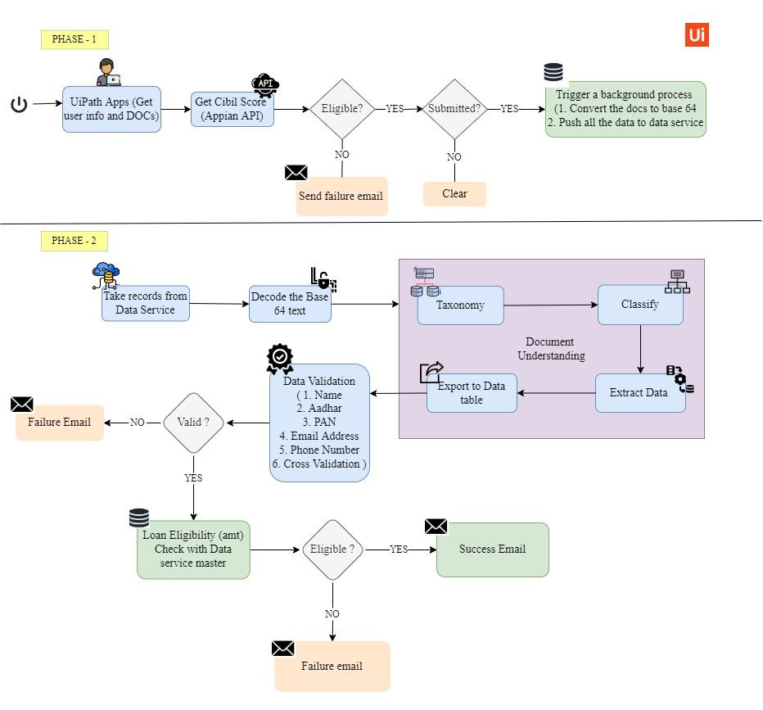

# Products Used

1. UiPath Apps
2. UiPath Studio
3. UiPath Data Services
4. UiPath Document Understanding
5. UiPath Orchestrator
6. UiPath Robot
7. Native Integrations – Gmail, API
8. Custom Reusable Component – Base64 Encoder & Decoder

# Process Steps:

## Phase 1:

1. Gets the details from the user and the path for the following,

Basic Info:

* 1. First Name
  2. Last Name
  3. DOB
  4. Gender
  5. Age
  6. Marital Status
  7. Address
  8. Post Code
  9. Phone
  10. Email
  11. PAN

Loan Details:

* 1. Loan Type
  2. Loan Amount

Org Details:

* 1. Org name
  2. Designation
  3. Employment Type
  4. Experience Total

Documents:

* 1. Aadhar Card
  2. PAN Card
  3. Pay-slip
  4. Salary-slip

1. On submitting the application, it triggers a background process.
2. This process checks if the following information is valid,
   1. Phone number
   2. Email Address
   3. PAN number
3. Then with the PAN number, it uses an API to get the user’s current Cibil score and gets the required Cibil score for the type of Loan the user has selected.
4. If the user meets the criteria, then the process proceeds.
5. If the user fails to meet the criteria, an email will be sent to the user with failure details and then the process is stopped.
6. For valid scenarios, the following documents are checked for existence and encoded,
   1. Aadhar Card
   2. PAN Card
   3. Pay-slip
   4. Salary-slip
7. Then, the user details and the encoded documents are pushed to the Data service.
8. Finally, an email will be sent to the user about the confirmation of their successful submission.

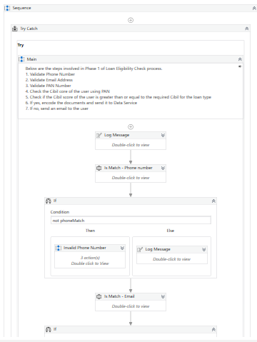

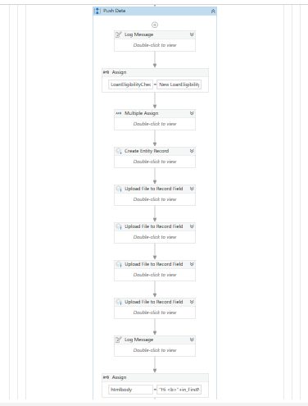

## Phase 2:

1. The records that were pushed by the Phase1 bot will be retrieved and processed one-by-one.
2. The data is retrieved, and the documents are decoded and moved to a folder.
3. Those files will be fed into a document understanding framework.
4. The documents are classified based on their corresponding categories and the data is extracted using the Form Extractor.
5. The extracted data is then cross validated across all the documents
6. If the validation is successful, then proceed.
7. If the validation is unsuccessful, then send an email to the user and stop the process.
8. For success scenarios, the loan eligibility check is performed as follows,
   1. From the Loan Master in the Data service, get the Maximum Allowed Loan amount value against the user’s Salary limit
   2. If the required Loan Amount filled by the user is less than or equal to the allowed limit, then it will be considered as a success case
   3. If the required Loan Amount filled by the user is greater than the allowed limit, then it will be considered as a failed case
9. Emails will be sent in both cases, to inform the user about the results.
10. The process records will be moved to the new table in the Data Service

# Benefits:

* Average processing time for one request end-to-end is ~1 minute which reduces the waiting and processing time greatly.
* Runs completely unattended and in the background only (users can still use the system for other productive tasks)
* The documents are Encoded and decoded only when the data is extracted from them.
* Time and space saving
* The end-to-end process is split into two phases for better separation of concerns.
* The success and failures will be notified to the end users promptly.

# Screenshots:

Sample Form

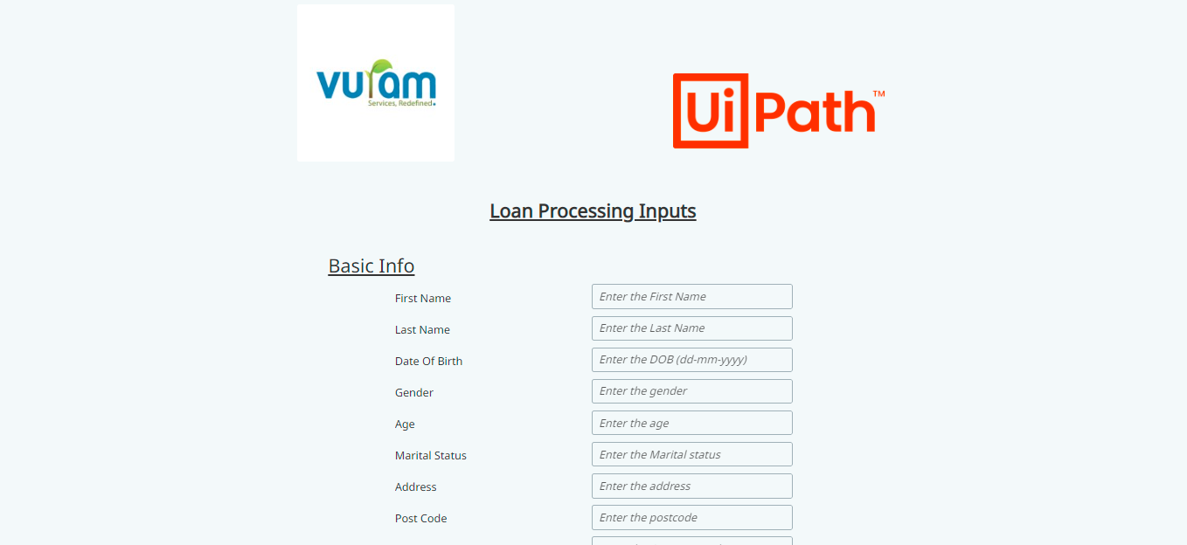

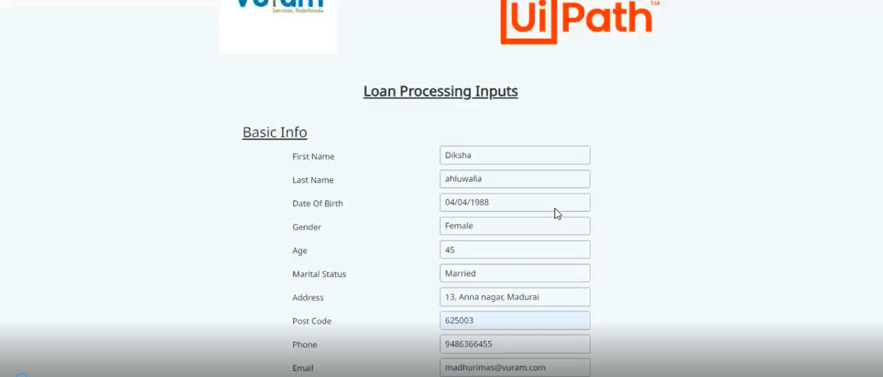

Sample User Cibil Master

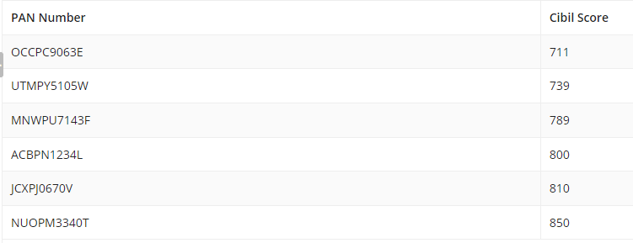

Sample Loan Master

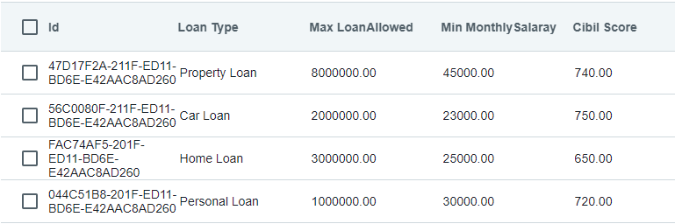

Sample New Data in Data Master

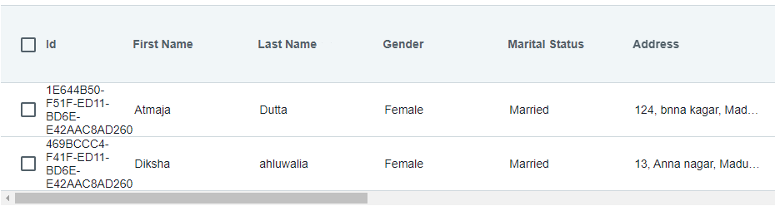

Sample Success Email – phase1

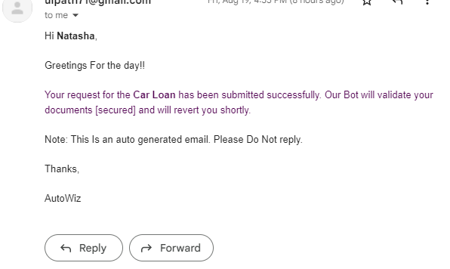

Sample Failure Email – phase2

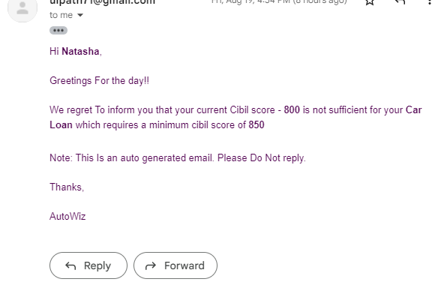

Sample Success email – phase2

